Thank you for your interest in becoming a Watershed Stewards Program (WSP) Placement Site. In our 28th year, we are looking to partner with organizations throughout California to host a total of 44 WSP Corpsmembers from October 3rd, 2021 through August 18th, 2022. Placement Sites have a unique opportunity to support and mentor developing environmental professionals as they begin their careers.

Directions:
The purpose of this application is for your organization to give the Watershed Stewards Program (WSP) a thorough idea of how you propose to utilize WSP Corpsmembers and what the Corpsmember experience will be like at your site.

Please review all content on the Placement Site Applicants page of WSP’s website before completing this application. The quality of your application will be taken into careful consideration, and much of the information you provide may be shared directly with Corpsmember applicants.

Complete the following application electronically and submit to wsp.info@ccc.ca.gov no later than 5pm, Friday, February 5th, 2021.

Documents Required for Application:
☐ Year 28 Placement Site Application (this document)
☐ One-page résumés for Site Supervisor and all Mentors listed on this application (if not already on file with WSP)

WSP Corpsmembers are not employees of WSP Placement Sites, and should not perform administrative functions. Corpsmembers must serve a unique role in your organization and focus on meeting a critical unmet community need. Placement Sites are prohibited from replacing an existing employee position with a WSP Corpsmember position, per AmeriCorps guidelines.

Do you agree to these terms?
☐ Yes ☐ No

PLACEMENT SITE INFORMATION
Placement Site Name: This is the name WSP will use in regular correspondence, recruitment, etc.  Click here to enter text. | Contracting Organization Name: Please list the organization that WSP will complete contracting with. If multiple organizations or agencies are involved, please detail the relationship and responsible parties below.  Click here to enter text.
Placement Site Physical Address: Location of WSP Member office  Click here to enter text. | Placement Site Mailing Address: If different than physical address  Click here to enter text.
Organization’s Website: Click here to enter text.
Number of Corpsmembers Requested: Choose an item.

Placement Site Status (new or reapplying site): Choose an item.
Re-Applying Placement Site:
Number of years your organization has hosted WSP Corpsmembers: Choose an item.
New Placement Site:
If you answered No to either of the questions below, please contact WSP at 707-725-8601 before continuing with this application.
Have you met with WSP staff to discuss the program?
☐ Yes ☐ No

Has WSP staff visited your proposed Placement Site?
☐ Yes ☐ No
Watershed(s) served by proposed Corpsmember activities – a least one must be an FRGP Priority Anadromous Watershed
See Table starting on page 21, column titled “PI” are all WSP priority watersheds.
Placement sites must specify all watershed(s) Corpsmember may serve.
Click here to enter text.
PLACEMENT SITE CONTACT INFORMATION
Primary Placement Site Contact:
This person will be WSP’s primary point of contact throughout the application review and contracting process.
Name: Click here to enter text. | Title: Click here to enter text.
Email Address: Click here to enter text. | Phone Number: Click here to enter text.
Contracting Contact:
Please list the person who is certified to sign the contract and whose name should be listed on the contracting documents.
Name: Click here to enter text. | Title: Click here to enter text.
Email Address: Click here to enter text. | Phone Number: Click here to enter text.

Mailing Address: Click here to enter text.
Notes: Use this space to tell us about any special circumstances with contracting or billing, such as multiple agencies being involved, split amounts, different names on different documents, different billing address, timelines for contracting, etc. Please be as specific and detailed as possible.
Click here to enter text.

PLACEMENT SITE PARTICIPANT INFORMATION
Review the Placement Site participant definitions below and indicate who will be responsible for each position.
You must submit résumés for all people listed below. (if not already on file with WSP)
Site Supervisor (one required):
Responsible for overall Placement Site, Corpsmember, and Mentor supervision, as well as general program compliance. The Site Supervisor may not necessarily have daily contact with Corpsmembers, but is ultimately responsible for all WSP program requirements, including the timely submission of paperwork by Mentors and Corpsmembers.
NOTE: This position cannot be filled by the same person listed as a Mentor.
Site Supervisor Name: Click here to enter text.  Email: Click here to enter text. |  |  |  | Title: Click here to enter text.  Phone: Click here to enter text.
WSP Alumni: |  | ☐ Yes ☐ No |  | Number of years as a WSP Site Supervisor: Click here to enter text.
Mentors (at least one required; no more than four):
Provides direct Corpmember supervision and guidance; completes and submits all required WSP paperwork.
Refer to the Mentor Position Description for qualifications.
 | Mentor Name: Click here to enter text.  Email: Click here to enter text. |  |  | Title: Click here to enter text.  Phone: Click here to enter text.
 | WSP Alumni: |  | ☐ Yes ☐ No | Number of years as a WSP Mentor: Click here to enter text.
 | Mentor Name: Click here to enter text.  Email: Click here to enter text. |  |  | Title: Click here to enter text.  Phone: Click here to enter text.
 | WSP Alumni: |  | ☐ Yes ☐ No | Number of years as a WSP Mentor: Click here to enter text.
 | Mentor Name: Click here to enter text.  Email: Click here to enter text. |  |  | Title: Click here to enter text.  Phone: Click here to enter text.
 | WSP Alumni: |  | ☐ Yes ☐ No | Number of years as a WSP Mentor: Click here to enter text.
 | Mentor Name: Click here to enter text.  Email: Click here to enter text. |  |  | Title: Click here to enter text.  Phone: Click here to enter text.
 | WSP Alumni: |  | ☐ Yes ☐ No | Number of years as a WSP Mentor: Click here to enter text.

FUNDING
Match Amount Required:  WSP offers a sliding scale to allow a diverse group of partner organizations to serve our watersheds and communities. | ☐ Agency ($16,500 - $18,500)  Enter dollar amount your site will pay per Corpsmember here  ☐ Agency with Housing  ($15,300 – $18,500)  Enter dollar amount your site will pay per Corpsmember here  ☐Non-Profit  ($11,500 - $15,500)  Enter dollar amount your site will pay per Corpsmember here  ☐ CDFW limited number of funded positions through FRGP | Funding  Status: (Required)  ☐ Secure  ☐ Unsecure

For Unsecure Funding Status:
Please provide details, including when you expect to secure funding. Placement Sites must have secure funding before contracting paperwork can be initiated. Please contact WSP with your funding status updates by May 15th, 2021.
Click here to enter text.
☐ Site can provide additional in-kind support/funding (optional).
Please define any in-kind support/additional funding amount your organization would like to contribute beyond the site match listed above. Additional funds will be used for general program operations (Corpsmember gear, outreach materials, training, tools, etc.)
Click here to enter text.

APPLICATION QUESTIONS
Please read the Corpsmember Activity Descriptions on the WSP website before answering the following questions.
WSP Corpsmembers spend approximately 72% of their service term working on projects for, and with, their Placement Site. The majority of this time should be spent working on watershed recovery and protection projects. The other 28% of Corpsmembers’ service term is spent on WSP-related projects, such as teaching the Wonders of Watersheds (WOW!) curriculum, planning and implementing their Watershed Awareness Volunteer Event (WAVE), conducting community outreach, and attending WSP trainings.
Provide a brief description of your organization and the work you do:
If you are a new applicant, please also describe how you learned about WSP and if you have ever worked with WSP Corpsmembers before.

Click here to enter text.
Write a brief and thorough description of the style of mentorship you will provide:
If mentorship will be split between Corpsmembers, by seasons, or by task, please describe in space below. Your response may be shared with WSP Corpsmember Applicants.

Click here to enter text.
Write a brief and thorough description of what Corpsmembers will do at your Placement Site. WSP’s primary performance measure is to treat and improve salmonid habitat, please address if/how Corpsmembers at your site will participate in hands-on restoration projects.
Your response may be provided to WSP Corpsmember Applicants. Include Watershed Recovery and Protection work, as well as Site-specific education, outreach, volunteer recruitment and management, and Corpsmember training opportunities, as appropriate.
Do not list WSP activities or trainings such as teaching WOW!, organizing a WAVE, and WSP-specific trainings.

Click here to enter text.

State the reasons your organization and community need WSP Corpsmembers.
Include a justification for the number of Corpsmembers you are requesting and explain any flexibility you have in the number of Corpsmembers requested.

Click here to enter text.
What makes your Placement Site unique and distinguishes the Corpsmember experience from other organizations?
Your response may be provided to WSP Corpsmember Applicants. If your site is made up of several organizations and Corpsmembers will serve in different locations under varied Mentors, describe the partnership, what Corpsmembers will do with each organization, and the percentage of time Corpsmembers will work with each organization. Please note, WSP may request to contract with each organization. Be as specific as possible.

Click here to enter text.
Fill out the following chart with the percentage of time Corpsmembers will spend working 8, 10, and 10+ hour days.
This should be an average for the year, and the chart must total 100%.

WORK HOURS
8-hour days | 10-hour days | 10+ hour days
Click here to enter text.% | Click here to enter text. % | Click here to enter text. %

Fill out the following chart with the percentage of time Corpsmembers will spend working on the listed activities.
Please only account for Site-specific projects – do not count WSP-trainings, WOW!, or WAVE. This should be an average for the year, and the chart must total 100%.

TYPE OF WORK
Field Work  (e.g.: field surveys, planting, invasive pulls, maintenance, water conservation projects) | Office Work  (e.g.: lab analysis, data entry, GIS, report writing) | Commuting  (e.g.: travel to field work and project sites) | Education and Outreach  (e.g.: non-WOW! teaching, tabling, citizen science) | Volunteer Recruitment & Management  (e.g.: non-WAVE volunteer work) | Corpsmember  Training  (e.g.: Site-specific training, conferences, and development opportunities) | Other  (e.g.: gear and equipment maintenance)
Click here to enter text. % | Click here to enter text. % | Click here to enter text. % | Click here to enter text. % | Click here to enter text. % | Click here to enter text. % | Click here to enter text. %

Indicate on the following table how much time Corpsmembers at your site will spend on the listed activities. Account for all activities that Corpsmembers do during the year including their WSP requirements (teaching the WOW! series, organizing their WAVE, etc.). For example: if your site has Corpsmembers complete the minimum WSP education requirements (teaching the WOW! series in 1 classroom), and your site does not conduct any additional education, you would mark the first activity (teaching students in a classroom setting) as a 2.

Please use the following guidelines:
1: Your Corpsmembers will spend no time on this activity during their year (0 hours)
2: Your Corpsmembers will spend a small amount of time on this activity during their year (1 – 50 hours)
3: Your Corpsmembers will spend a moderate amount of time on this activity during their year (50 – 200 hours)
4: Your Corpsmembers will spend a large amount of time on this activity during their year (200 – 500 hours)
5: Your Corpsmembers will spend a very large amount of time on this activity during their year (500+ hours)

Activity | Amount of Time
Teaching students in a classroom setting. | No time 1 ☐ 2 ☐ 3 ☐ 4 ☐ 5 ☐ A lot of time
Leading students on field trips and outdoor learning experiences. | No time 1 ☐ 2 ☐ 3 ☐ 4 ☐ 5 ☐ A lot of time
Conducting community outreach (leading guided tours, assisting with community events, tabling, etc.). | No time 1 ☐ 2 ☐ 3 ☐ 4 ☐ 5 ☐ A lot of time
Fisheries work (spawner surveys, trapping, electrofishing, migrant trapping, habitat surveys, weir operation, snorkel surveys, PIT tag antennae operations, trawling, etc.). | No time 1 ☐ 2 ☐ 3 ☐ 4 ☐ 5 ☐ A lot of time
Working on water conservation projects (rainwater gardens, rainwater catchment, Bioswales,tc.). | No time 1 ☐ 2 ☐ 3 ☐ 4 ☐ 5 ☐ A lot of time
Planning restoration projects (writing and reviewing plans, attending meetings, assisting with grants, writing reports, landowner outreach, etc.). | No time 1 ☐ 2 ☐ 3 ☐ 4 ☐ 5 ☐ A lot of time
Monitoring stream flow and water quality (drought monitoring, stormwater monitoring, water-quality testing, maintaining monitoring equipment, etc.). | No time 1 ☐ 2 ☐ 3 ☐ 4 ☐ 5 ☐ A lot of time
Implementing instream restoration projects (installing large woody debris, removing passage barriers, etc.). | No time 1 ☐ 2 ☐ 3 ☐ 4 ☐ 5 ☐ A lot of time
Implementing upslope and riparian restoration projects (planting native plants, nursery work, pulling invasive species, riparian enhancement, erosion control, etc.). | No time 1 ☐ 2 ☐ 3 ☐ 4 ☐ 5 ☐ A lot of time
Recruiting and managing volunteers. | No time 1 ☐ 2 ☐ 3 ☐ 4 ☐ 5 ☐ A lot of time
Using GIS (geographic information systems). | No time 1 ☐ 2 ☐ 3 ☐ 4 ☐ 5 ☐ A lot of time
Analyzing data and writing technical reports. | No time 1 ☐ 2 ☐ 3 ☐ 4 ☐ 5 ☐ A lot of time

Will your site be able to provide WSP Corpsmembers with affordable housing options? ☐ Yes ☐ No
If yes, describe the type of housing, cost to the Corpsmember, location, duration, contact information, and additional details below.
Click here to enter text.

Will your site be able to provide WSP Corpsmembers with a site vehicle? ☐ Yes ☐ No
Vehicles will only be used for field work and attending WSP events, not for personal use.
If yes, please provide more information below, including any limitations, and whether the vehicle would be available for Corpsmembers to take to schools and outreach events, or available only for field work. May the vehicle be used on overnight assignments?

Click here to enter text.
What is your site looking for in WSP Corpsmembers?
Please mark the boxes below to help us understand what your site is looking for in a Corpsmember. If your site has no preference about the items listed, please leave it blank. These skills and resources are not required by WSP.

Has a reliable vehicle | Preferred ☐ Required ☐
Strong swimmer | Preferred ☐ Required ☐
Ability to work weekends | Preferred ☐ Required ☐
Ability to go on regular overnight trips | Preferred ☐ Required ☐
GIS knowledge and experience | Preferred ☐ Required ☐
Specific field experience (fill in here):  Click here to enter text. | Preferred ☐ Required ☐
Other (fill in here):  Click here to enter text. | Preferred ☐ Required ☐

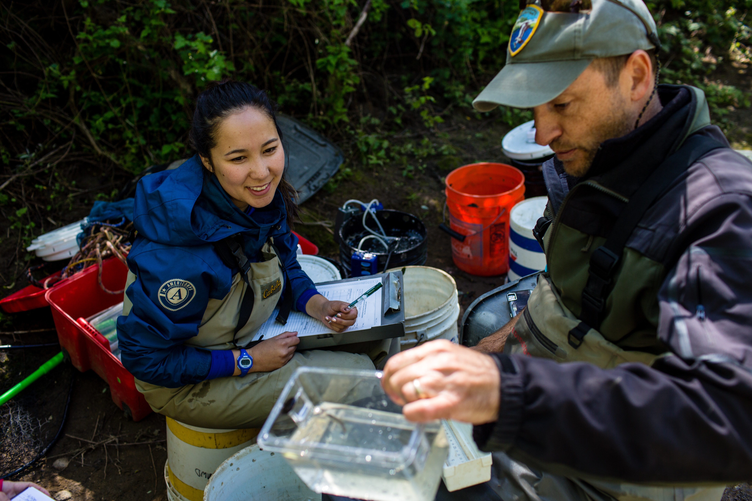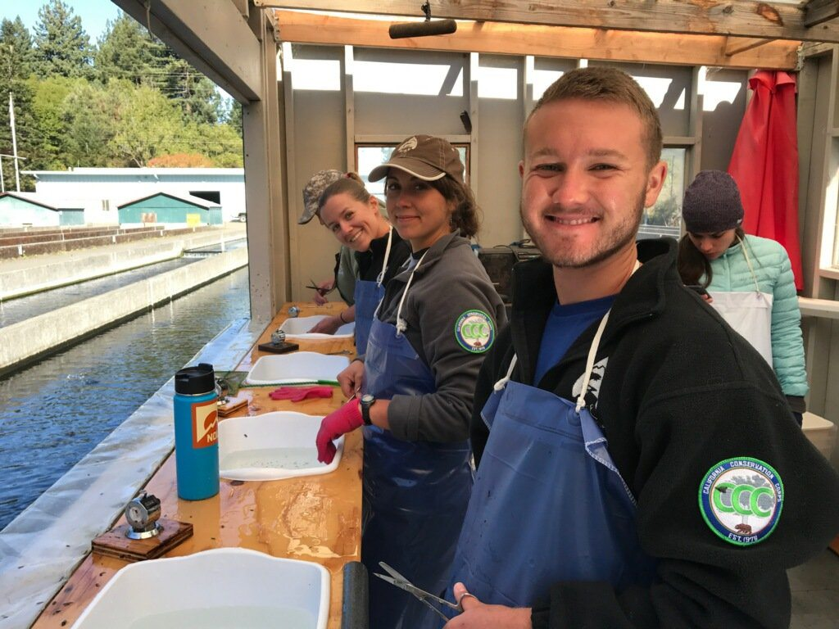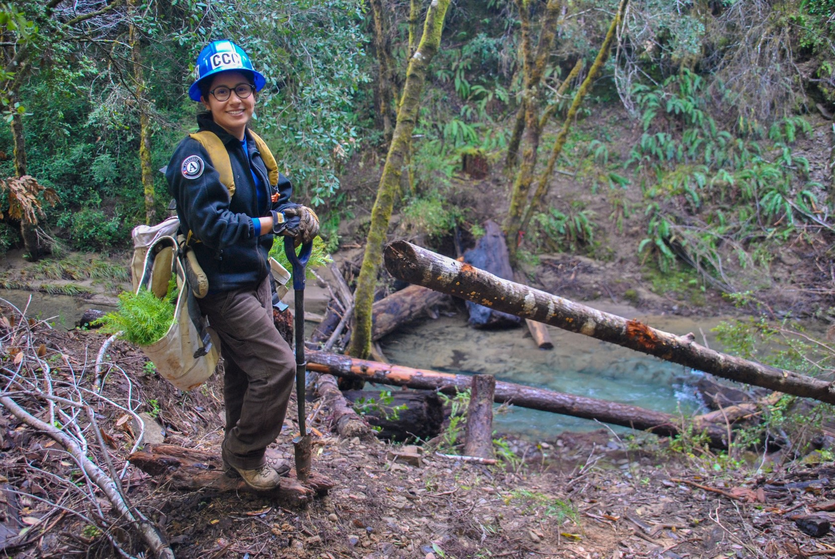

Thank you for your Year 28 WSP Placement Site Application!

